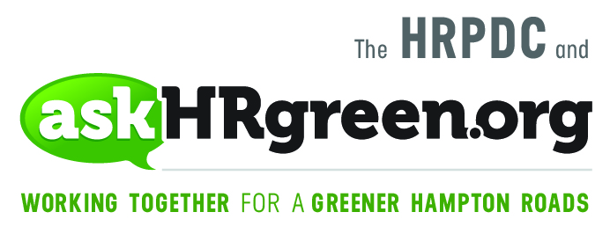

FOR IMMEDIATE RELEASE
Media Contacts:
Katie Cullipher, HRPDC Principal Environmental Education Planner
(757) 420-8300; kcullipher@hrpdcva.gov
Elizabeth Evans, Red Chalk Studios
(757) 705-7153; elizabeth@redchalkstudios.com

“Recycle More, Trash Less” at an
America Recycles Day Event Near You!
(Hampton Roads, Nov. 9, 2017) – The plastic bottle you are about to throw out with the trash could help reduce energy consumption, decrease pollution, create jobs and save our natural resources – if it were recycled instead. America Recycles Day, an initiative of Keep America Beautiful, is commemorated Nov. 15. Around that date, cities and counties across Hampton Roads celebrate by hosting a variety of recycling collection events, presenting a great excuse to clean out drawers, closets, offices and storage sheds!
The events differ by locality, but many include the collection of items that aren’t accepted for curbside recycling, such as electronics, plastic bags, ink and toner cartridges, household hazardous waste, documents for shredding, unwanted household items and clothing. Check the askHRgreen.org America Recycles Day event roundup to find out what’s happening in your community.
“We hope by celebrating America Recycles Day, and all the wonderful things it does for the region and our environment, it will inspire you to ‘recycle more, trash less’ all year long,” said Rebekah Eastep, askHRgreen.org team leader. “It helps municipalities operate more efficiently by reducing solid waste disposal fees, cutting back on the need to expand and build landfills and supporting and creating local jobs.”
Rules vary depending on where you live, but most Hampton Roads municipalities will accept clean paper and cardboard, metal cans and containers, glass bottles and jars, and plastic bottles. However, greasy takeout food containers (like pizza boxes), yard waste and plastic bags can never go in curbside bins. Plastic bags, in particular, can get tangled in the sorting machines at the recycling facility and quite literally bring things to a halt as they are removed from stopped-up machines. Instead, take them to one of the many local collection points, in grocery or big box stores, for recycling.
And if you’ve wondered what happens after you’ve filled up your recycling bin or dropped recyclables off at a collection event, here’s a rundown of where it all ends up:
- Electronics – disassembled into smaller parts for re-use or for making new products
- Paper products – shredded, stripped, bailed and used to make new paper products
- Plastic Bags – cleaned, bailed and used for making decks, fences and outdoor furniture
- Tires and rubber products – cleaned, granulated and turned into mulch for playgrounds and garden beds
- Ink and toner cartridges – cleaned, refilled and resold
- Paint – reformulated into new paint
- Clothing – donated garments that are not sold in stores such as Goodwill Industries are sorted, bailed and sold as reusable clothing, converted into rags or remade into new clothing
For an at-a-glance guide to what’s recyclable and what’s not, download the free poster at this link. Need more recycling tips and good-to-do practices? Just askHRgreen.org.

About askHRgreen.org
askHRgreen.org is your go-to resource for all things green in Hampton Roads – from recycling tips and pointers for keeping local waterways clean to water-saving ideas and simple steps to make local living easy on the environment. Launched in 2011, the region-wide public awareness and education campaign is administered through the Hampton Roads Planning District Commission and powered by the following members: The cities of Chesapeake, Franklin, Hampton, Newport News, Norfolk, Poquoson, Portsmouth, Suffolk, Virginia Beach, and Williamsburg; the counties of Gloucester, Isle of Wight, James City, Southampton, Surry and York; the town of Smithfield; and HRSD. Like askHRgreen.org on Facebook, follow on Twitter and Instagram, tune in to YouTube and catch the “Let’s Talk Green” blog, written by a team of local experts.

